Bartelso Elementary
5th ANNUAL PUMPKIN DECORATING CONTEST
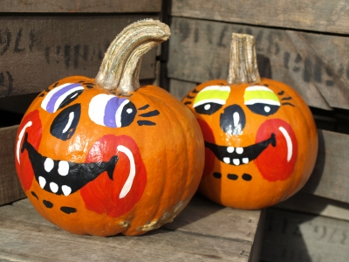
Friday, October 5th, 2018
Rules:
- Only one entry per student
- The main part of the entry must be a pumpkin
- Pumpkins may not be carved or hallowed out
- Pumpkins may not be larger than 2’X 2’X 2’
- Do not write your names on your pumpkins
- Use a school appropriate theme
- Objects, paper, and materials may be pinned or glued to your pumpkin. You may paint and draw on your entries. Again, no carving, or hallowed out pumpkin.
- No electrical outlets are available, battery operated devices are allowed if used.
- Entries must be turned in by Thursday, October 4th, 3:30pm
Who can participate? Any students in grades 4th-8th grade
Categories
Most Creative pumpkin Prettiest Pumpkin Scariest Pumpkin
All eligible entries will be judged on Grandparents Day on Friday, October 5th. Grandparents who attend the event will be able to vote for their favorite pumpkin. School faculty and staff will be included in the voting as well. The top winners in each category will have their pumpkin entered in the Breese Journal newspaper.
Prizes are awarded to the three category winners.
Each winner receives a bucket full of treats & a $15 boondocks gift card.
Pumpkins may be dropped off on WEDNESDAY, October 3rd and THURSDAY, October 4th either before or after school. If you ride the bus, you may bring your entries on the bus with you as long as you are careful. An adult or another student may assist you with transporting your pumpkin.
ALL Entries MUST be turned in by 3:30pm on THURSDAY, October 4th. No exceptions.
Entries will not be accepted on Friday, October 5th.
All pumpkin entry forms must be delivered to Mrs. Stefanisin (8th Grade/Science Teacher) along with your decorated pumpkin. Your pumpkin is not eligible to enter the contest if you do not have an entry form completed and signed by a parent/guardian. This form MUST accompany all pumpkins. Pumpkin entries and forms are due on Thursday, October 4th by 3:30pm along with your pumpkin.
WINNERS ANNOUNCED TUESDAY, OCTOBER 11th, 2017
------------------------------------------------------------------------------------------------------------------
Student Name: ________________________________________________________ Describe your entry: ________________________________________________
Homeroom Class: _____________________________________________________ ________________________________________________________________________
Parent Signature: ______________________________________________________ ________________________________________________________________________
Pumpkin Title: _________________________________________________________ All fields of this form must be filled in order to participate.
The tables that are set up have a number for each placement, where did you place your pumpkin? #________________

